Web Engineering / Frontend Development
Assignment 01 - Section B (CLO1 & CLO2)
Name | Muhammad Ali Hashir
Roll No | 241467
Project | Task Management & Activity Dashboard
Tech Stack | React (bundled with esbuild)
GitHub Repository | https://github.com/hashirworks/task-dashboard
Live Deployment | https://task-dashboard-qab2.vercel.app/

Task 1: Component-Based Architecture
The UI is split into small components using the required folder structure: components/class, components/functional, context, hooks and App.jsx.

Project folder structure
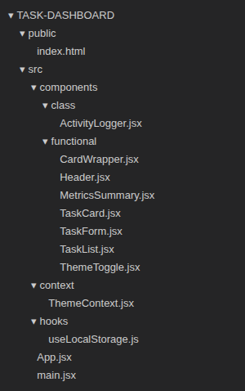

main.jsx
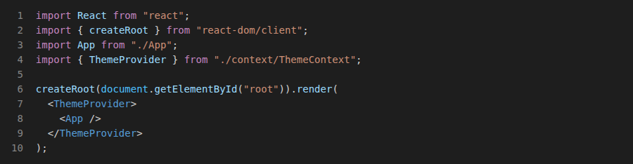

App.jsx
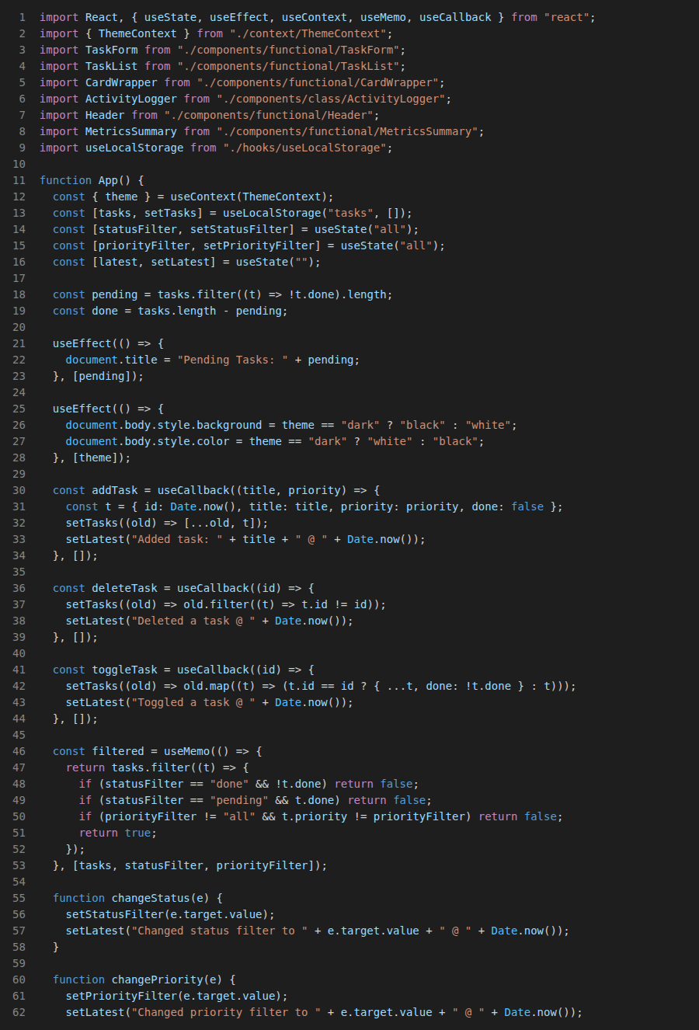
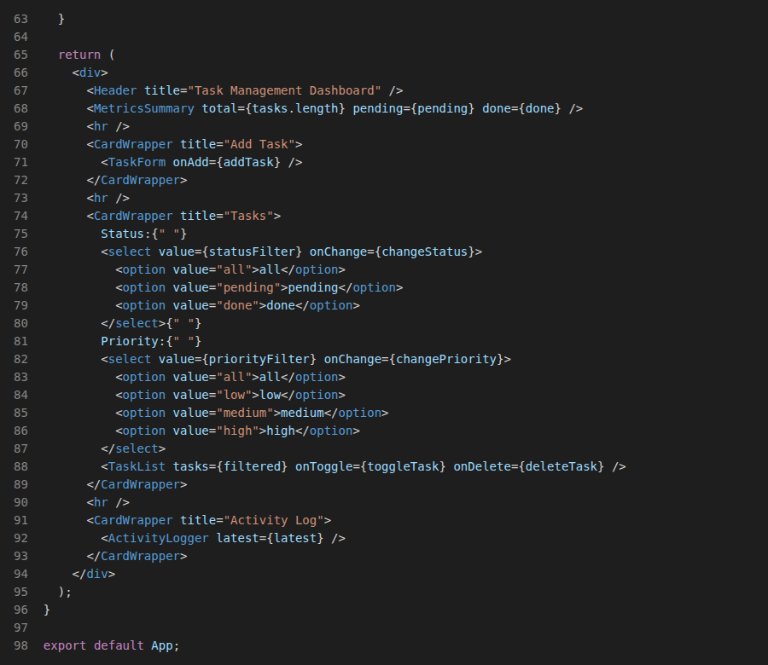

Output
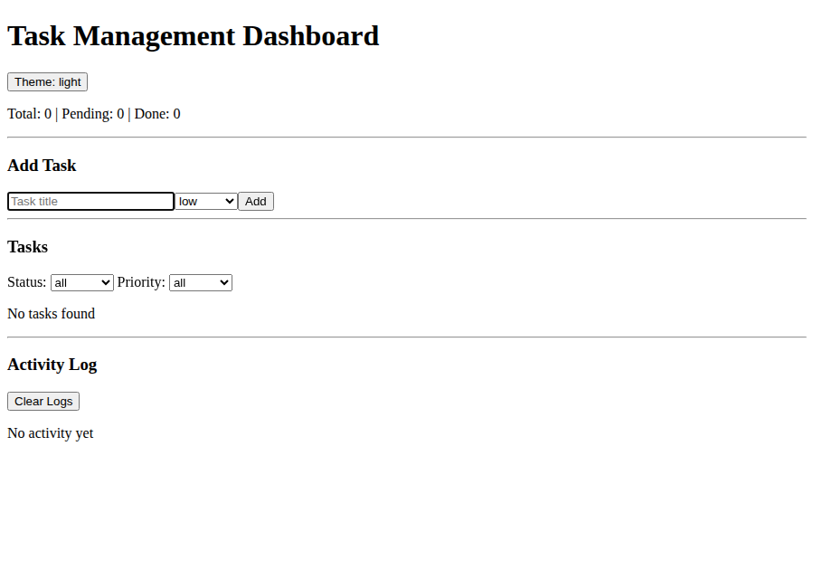
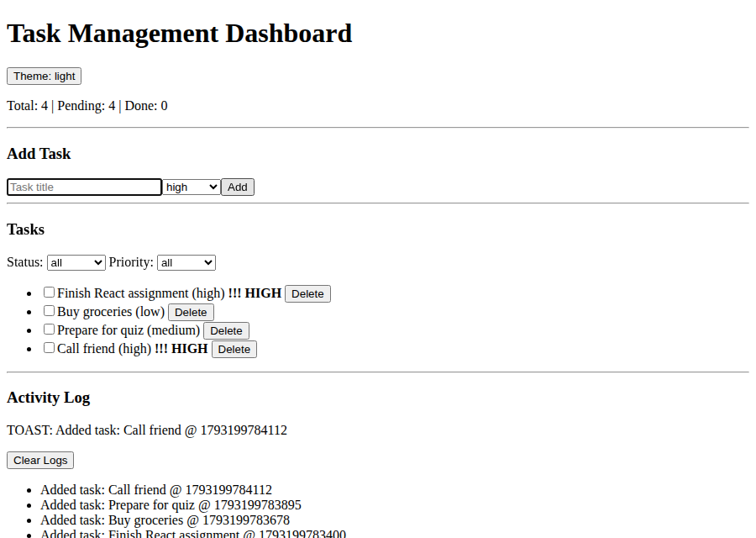

Task 2: Functional Components & Props
TaskForm, TaskList, TaskCard, Header, MetricsSummary and ThemeToggle are functional components. Data goes down with props and callback props (onAdd, onToggle, onDelete) send events up. CardWrapper uses props.children.

CardWrapper.jsx
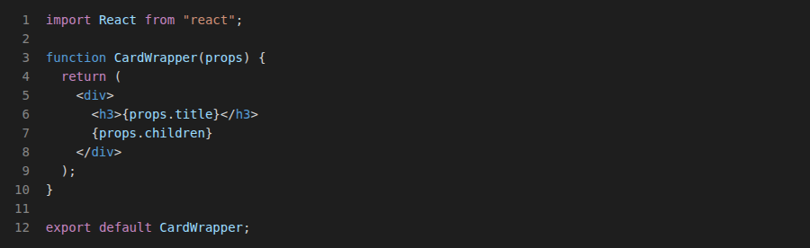

Header.jsx
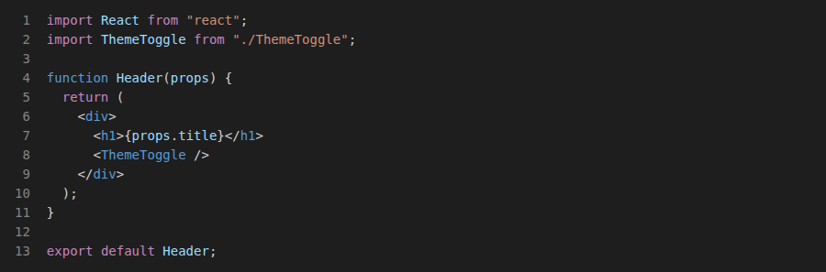

ThemeToggle.jsx
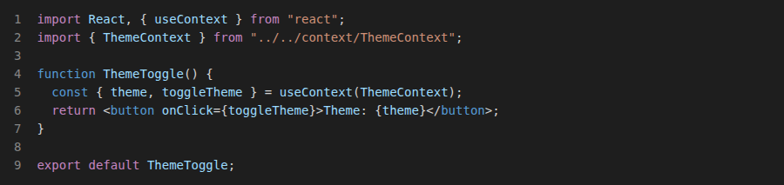

MetricsSummary.jsx
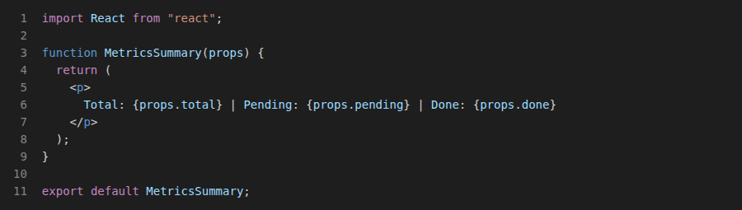

TaskForm.jsx
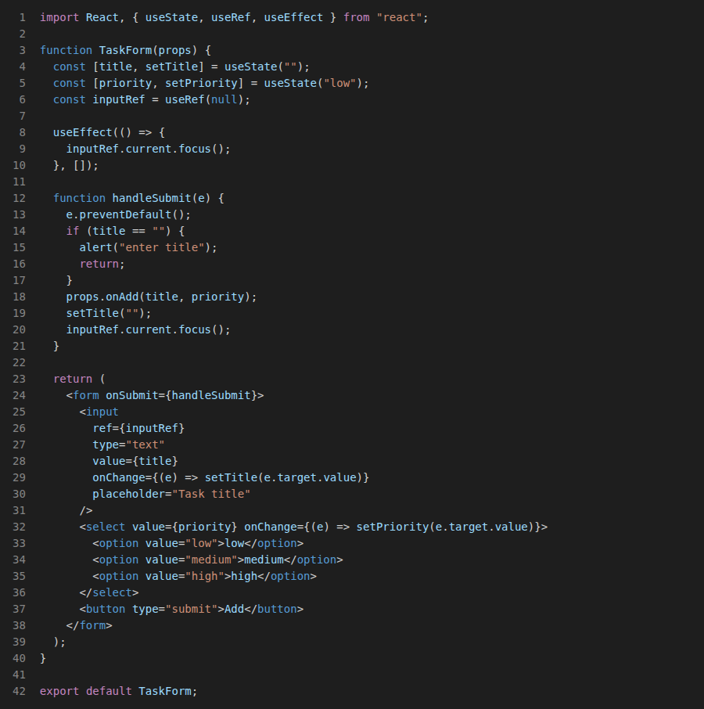

TaskList.jsx
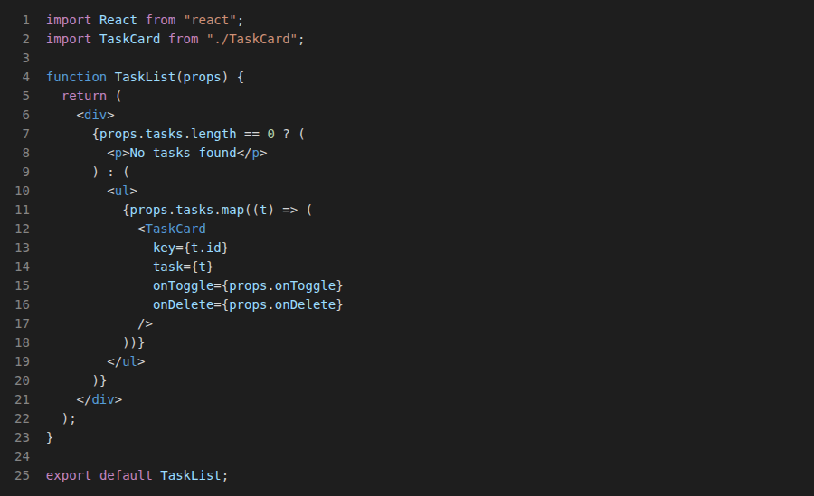

TaskCard.jsx
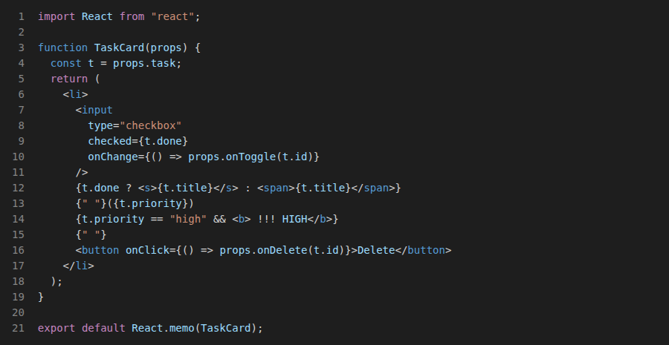

Output
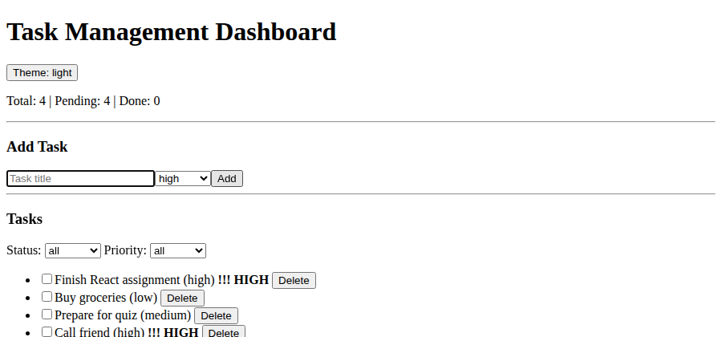

Task 3: Class Components & Lifecycle Methods
ActivityLogger is a class component using this.state and this.setState(). componentDidMount reads the logs from localStorage, componentDidUpdate saves new logs and shows a toast, componentWillUnmount clears the timer and removes the keydown listener.

ActivityLogger.jsx
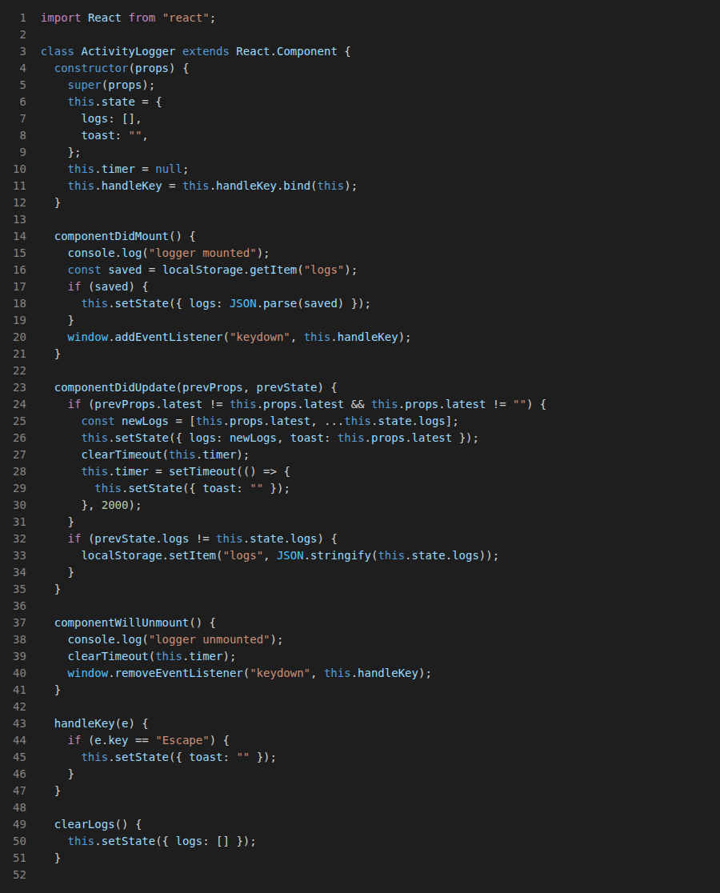
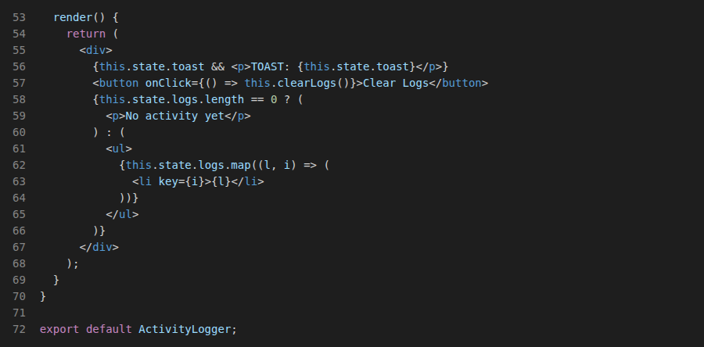

Output
Adding a task: log entry and toast message
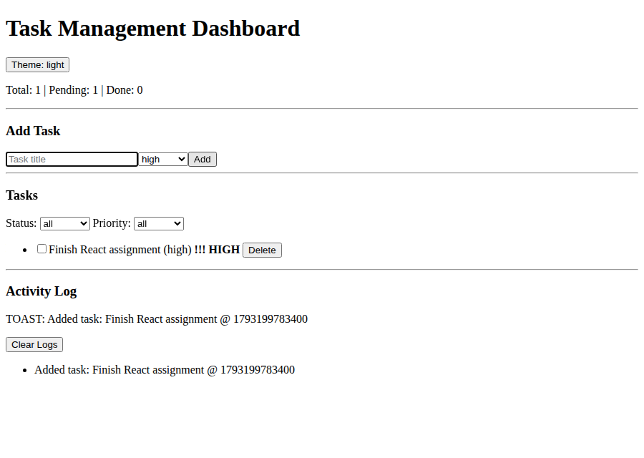
Deleting a task is logged
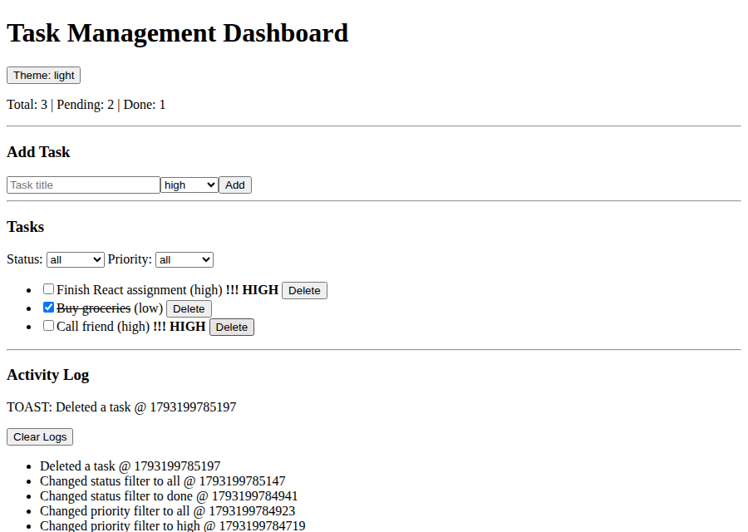
After page reload the logs are loaded back from localStorage
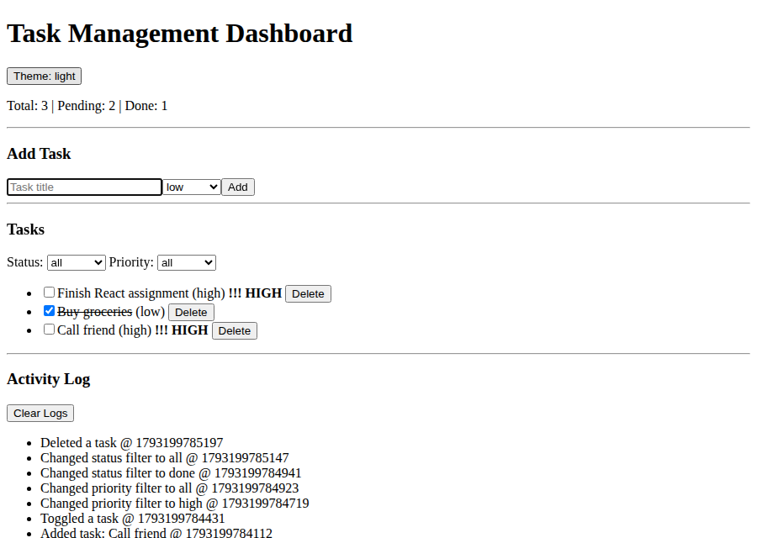

Task 4: JSX vs. JavaScript Logic
JavaScript expressions are used inside JSX with { }. Ternary operators are used for the empty state and done/pending text, && is used for the high priority indicator, lists use map() with unique keys, and onClick, onChange and onSubmit events are handled. The code for this is in TaskCard.jsx, TaskList.jsx and App.jsx shown above.

Output
Empty state (ternary)
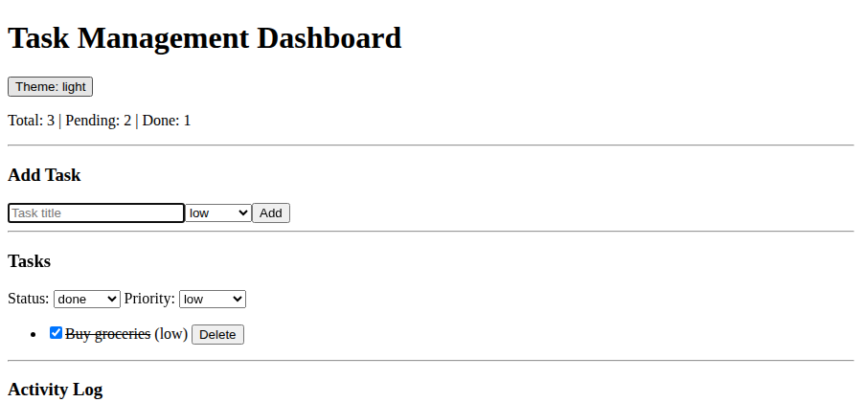
Done task is struck through, high priority tasks show !!! HIGH (&&)
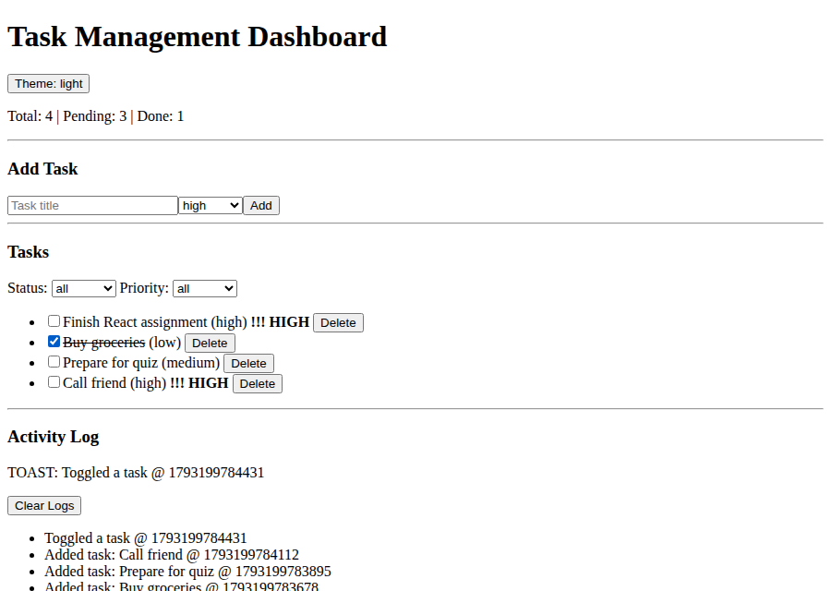
Priority filter = high
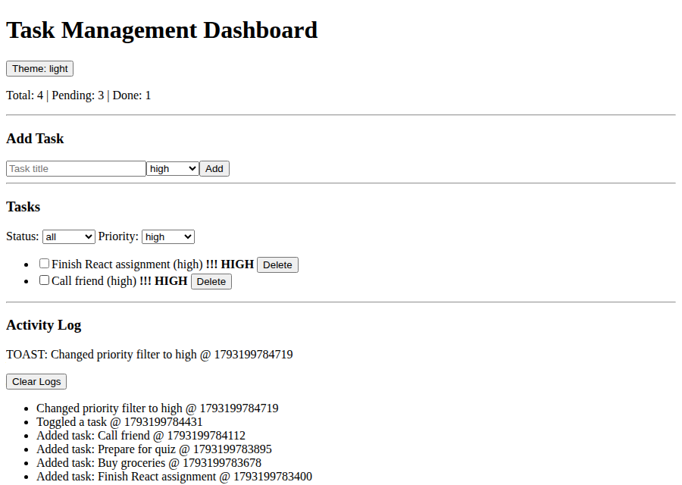
Status filter = done
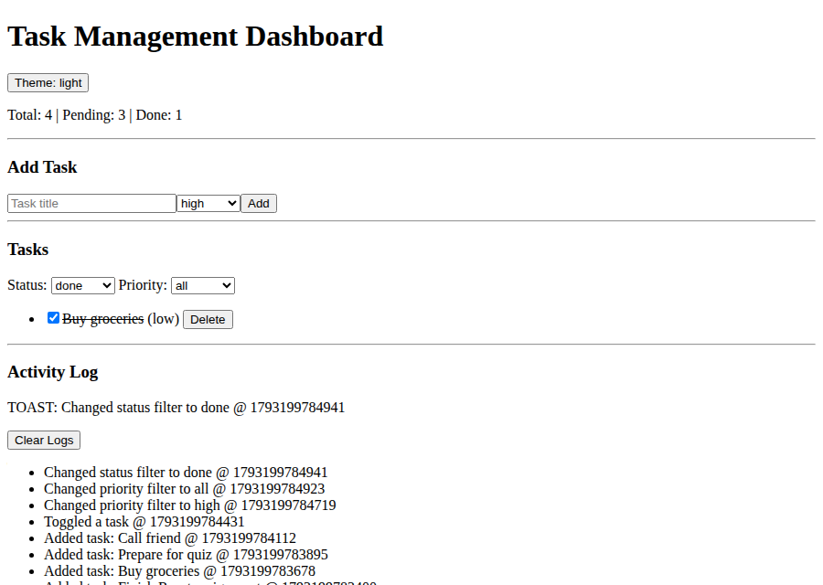

Task 5: React Hooks Mastery
useState (tasks, form inputs, filters), useEffect (localStorage sync and document title), useContext (ThemeContext), useRef (auto focus) and useMemo / useCallback (filtering and handlers). A custom hook useLocalStorage is also made in the hooks folder.

ThemeContext.jsx (useContext)
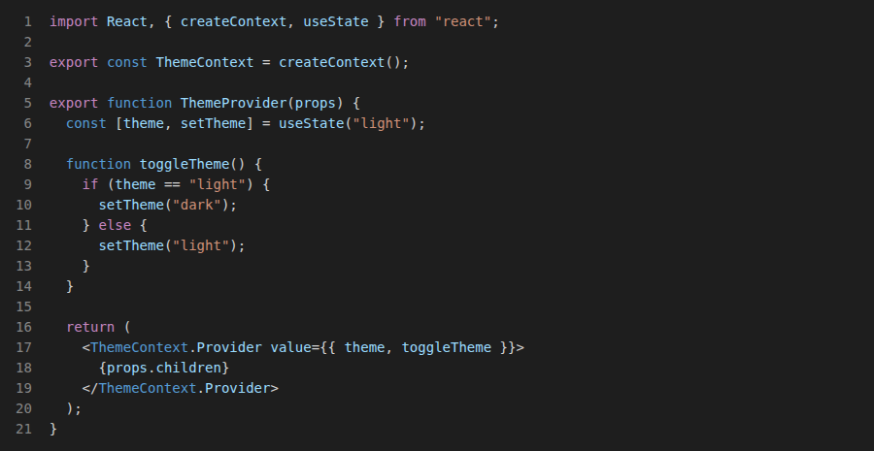

useLocalStorage.js (useState + useEffect)
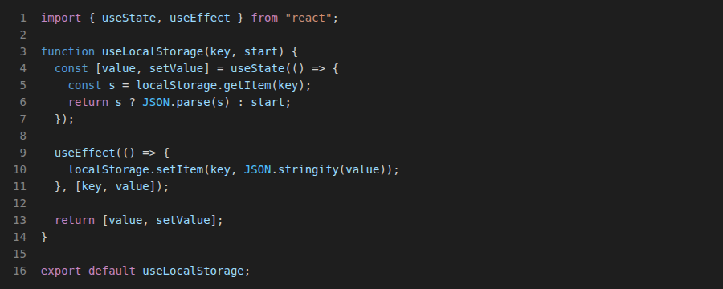

TaskForm.jsx (useRef) shown in Task 2, App.jsx (useState, useEffect, useCallback, useMemo) shown in Task 1

Output
useRef: input is focused automatically
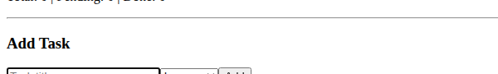
useContext: dark theme applied to all components
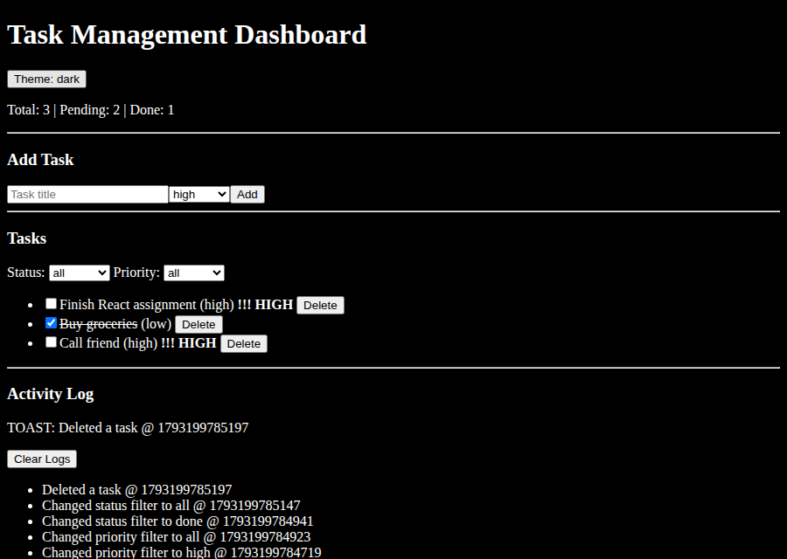
useEffect: browser tab title shows pending tasks count


